NET 731 Practical-Week 2
Project Overview
This capstone project simulates the role of an Azure Administrator responsible for designing, deploying, securing, and monitoring a cloud infrastructure using Microsoft Azure. Students must implement Azure services while ensuring the total cost remains within the $100 Azure for Students credit.
Week 2 (13–19 March) – Network Design (10 Marks)
• Create Virtual Network
• Configure address space and subnets
• Attach Network Security Group to subnets
• Upload network design documentation to GitHub

Create VNet
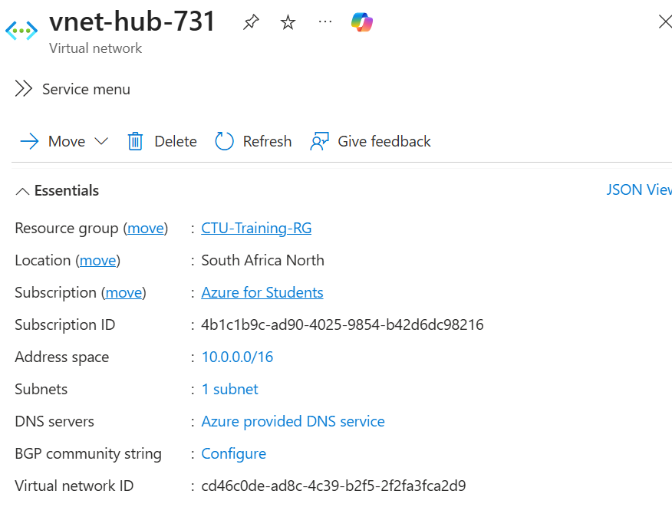

Configure address space and subnets
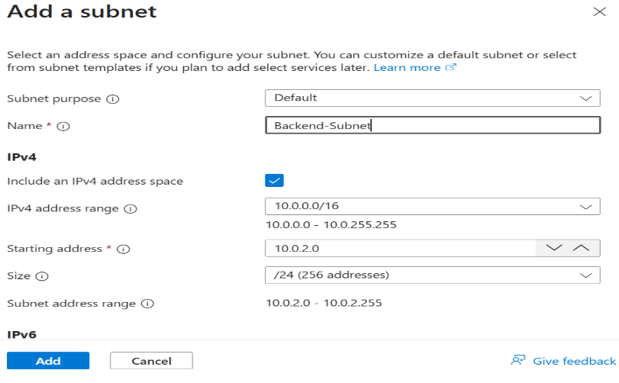
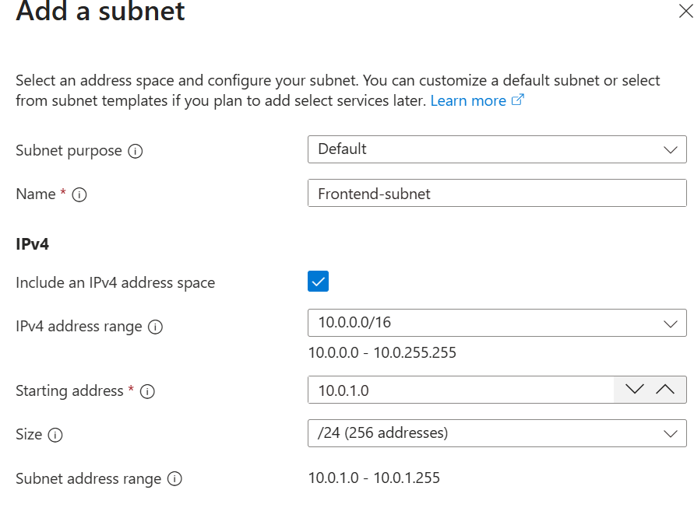

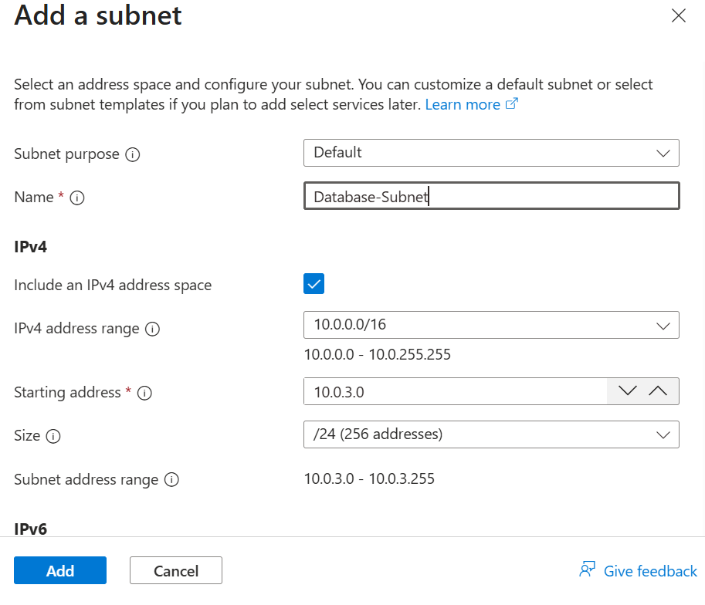
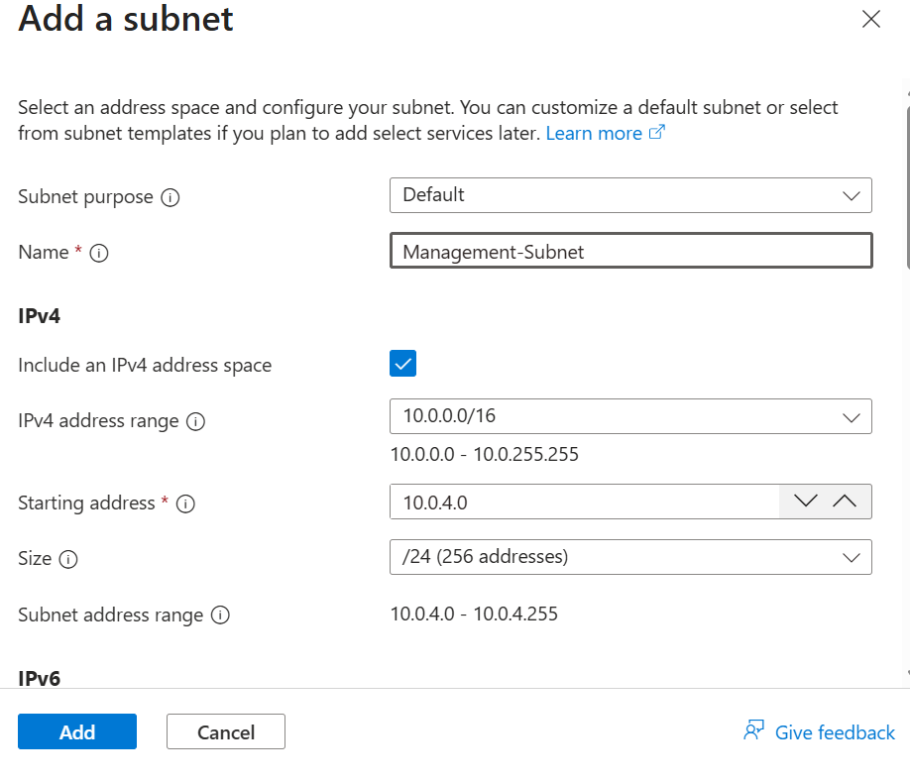

Create Network Security Group (NSG)

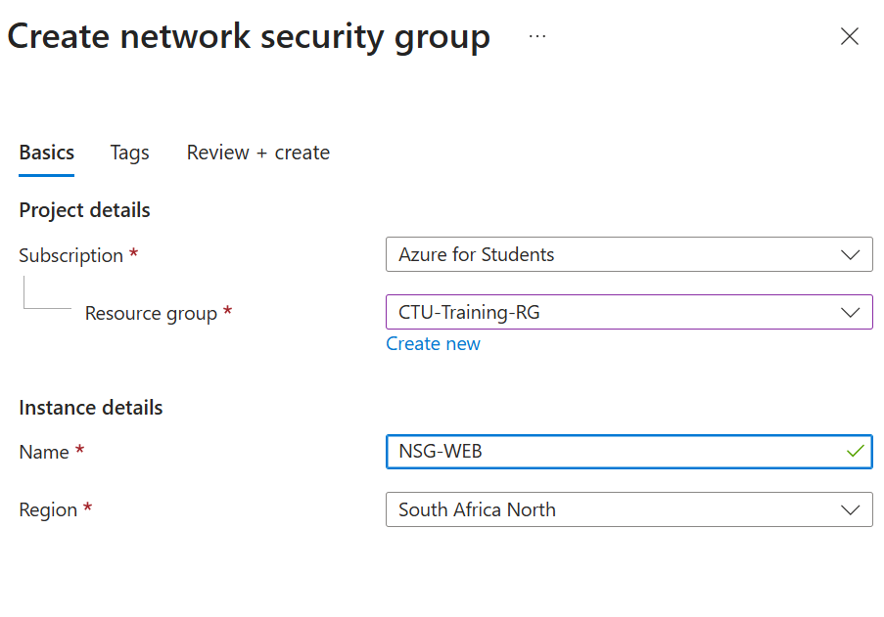
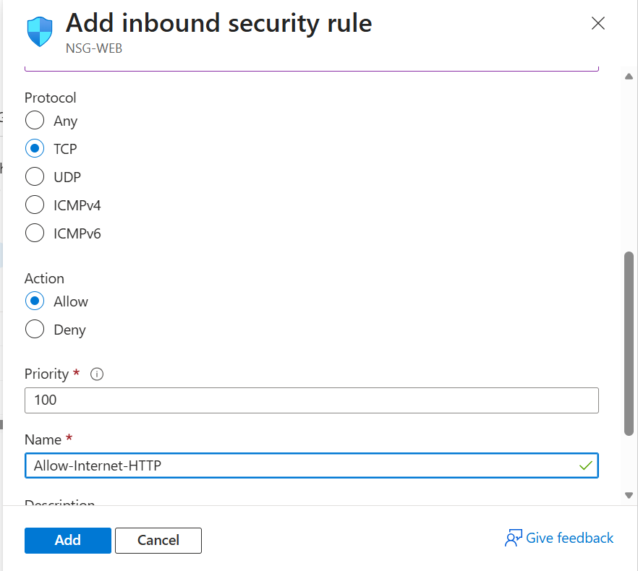

Attach NSG to Subnets
